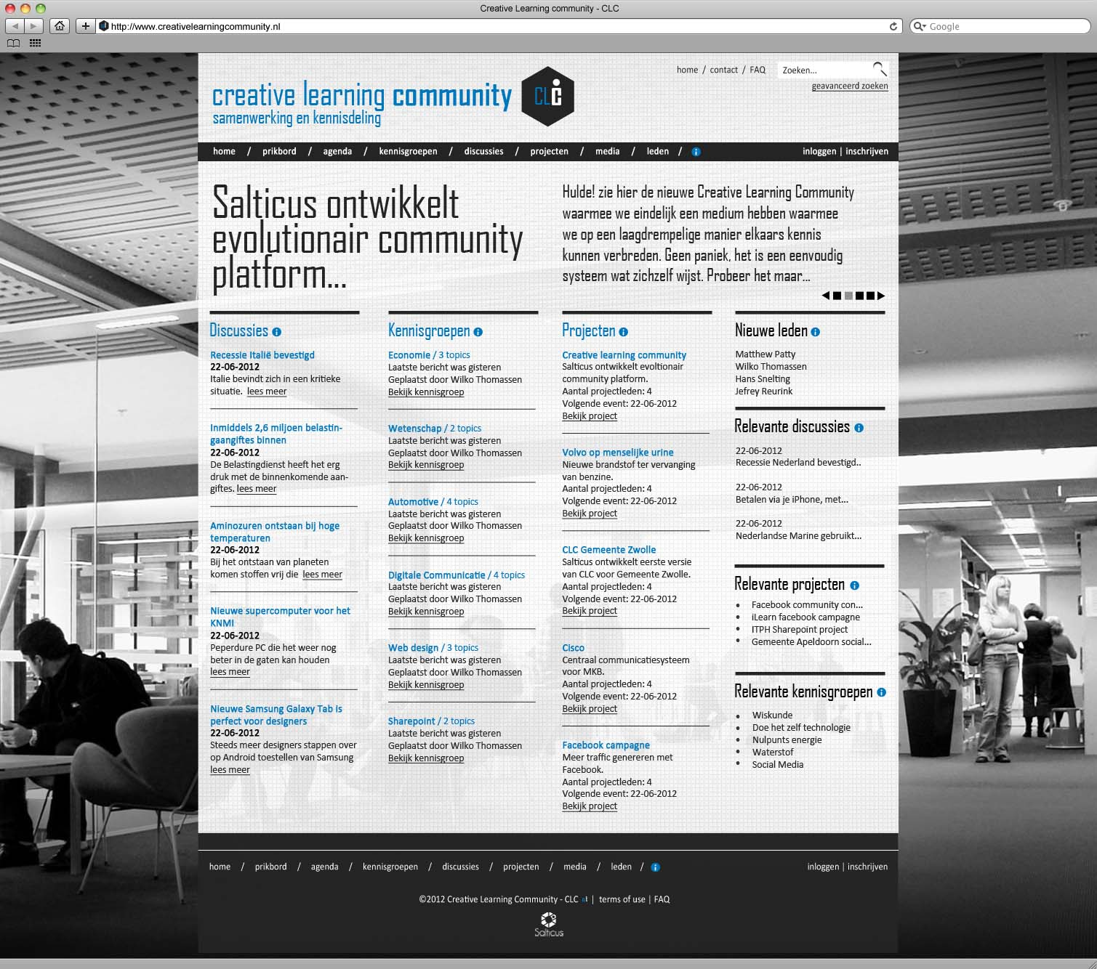
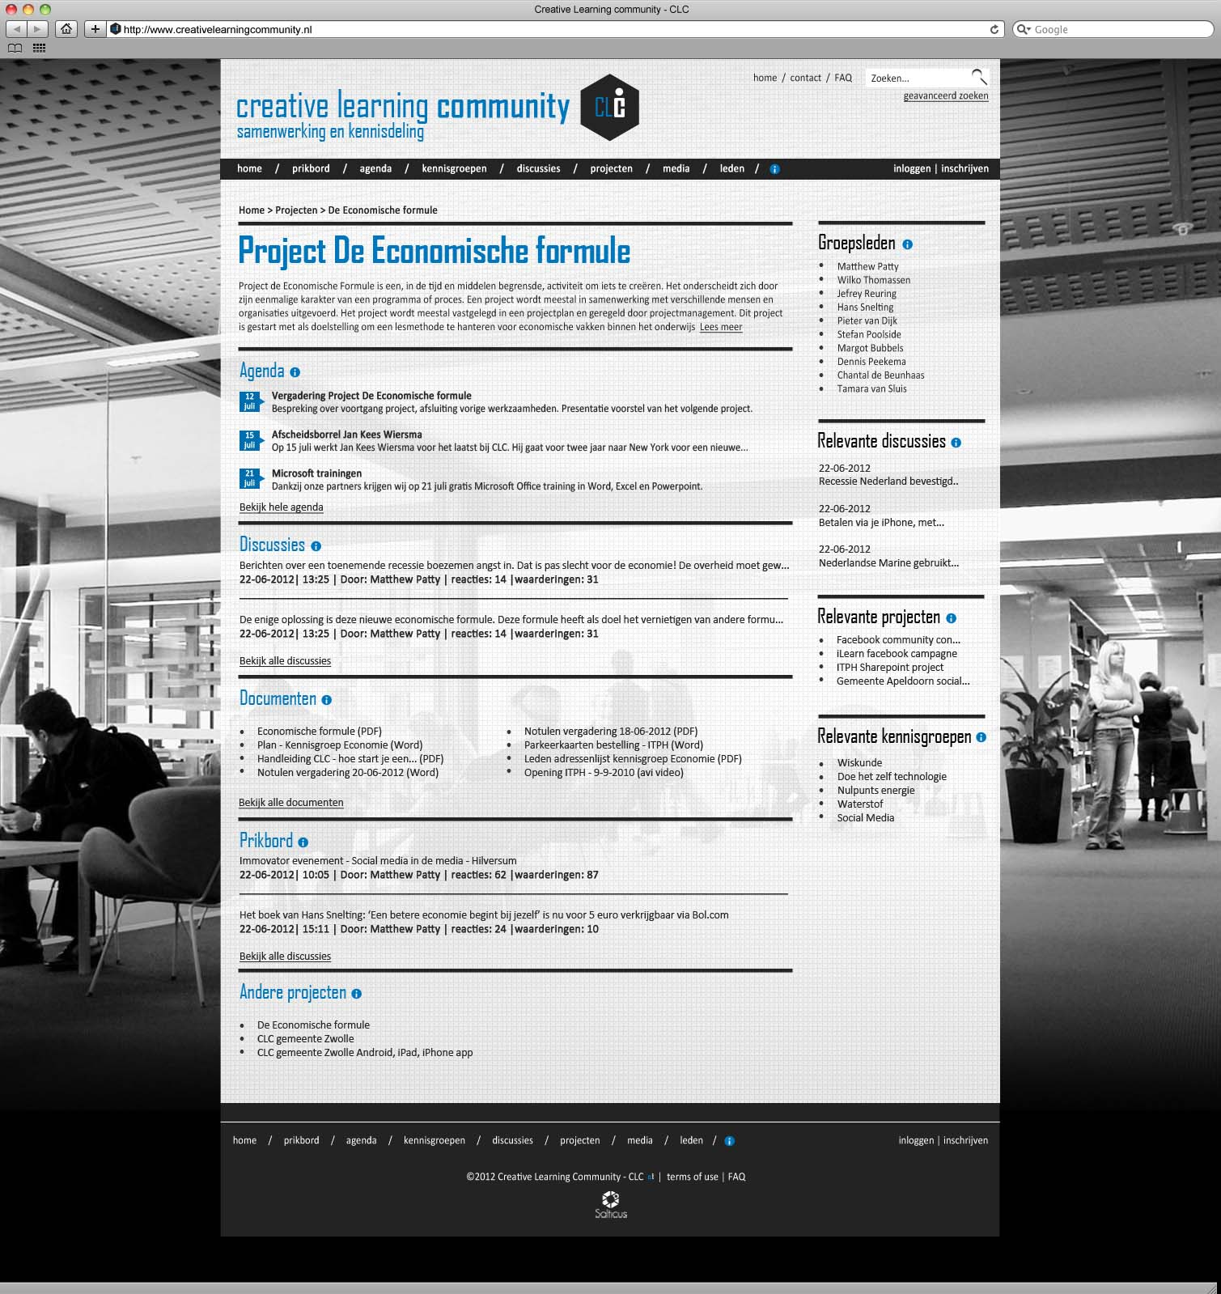

Algemene warden:
Favicon: | Favicon.ico
Achtergrond kleur: | #000000
Achtergrond afbeelding: | Background_website.png
 | Not repeated
 | Grootte bepalend aan resolutie
Achtergrond content: | Background_content.png
 | Repeated
Breedte: | 960px
Font: | Calibri
Font size: | 14px
Font color: | #242424

Links
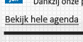
Links: | #242424
Underlined: | Ja
Hover: | #0077bd

Meta menu
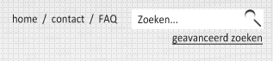
Menu
font color: #242424
spacer: /
Zoeken:  Zoekveld: 153x23  Zoek button: Button_zoeken.png | 
Geanvanceerd link:
Links: #242424
Underlined: ja
Hover: #0077bd

Website titel

Font: | Agency FB
Font color: | #0077bd
Font size (creative learning community): | 45px
Font size (samenwerking en kennisdeling): | 25px
Font weight (alleen community): | Bold

Mainmenu
Achtergrond kleur | #242424
font weight: | bold
font color: | #ffffff
spacer: | /
login/inschrijven spacer: | |

Slideshow

Titel:  Font color: #242424  Font: Agency FB  Font size: 60px | 
Introtext:  Font color: #242424  Font: Agency FB  Font size: 24px | 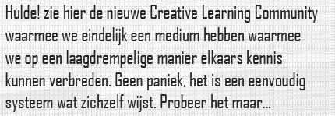
Slideshow indicators
Arrow left: slideshow_indicator_arrow_left.png
Arrow right: slideshow_indicator_arrow_right.png
Slide: slideshow_indicator_black.png
Slide now: slideshow_indicator_grey.png

Breadcrumbs
Links: | #242424
Underlined: | nee
Hover: | #0077bd
Font weight: | bold
Space: | >

Landsingspage – kolom subtitels en lees meer links
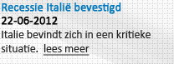
Subtitels:
Font color: #0077bd
Font weight: bold
Underlined: alleen hover
Datums
Font weight: bold

Pagina titel

Font: | Agency FB
Font color: | #0077bd
Font size: | 45px
Font weight: | Bold

Subtitles

Font: | Agency FB
Font color: | #0077bd
Font size: | 25px
Informatie button: | Button_info_13x14.png

Crosslinks titels

Font: | Agency FB
Font color: | #242424
Font size: | 25px
Informatie button: | Button_info_13x14.png

Agenda datums

Font size: | 11px
Achtergrond afbeelding: | background_agenda_date.png

Agenda titels/links
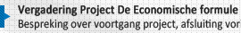
Font weight: | Bold
Hover: | #0077bd
Underlined: | ja

Footer
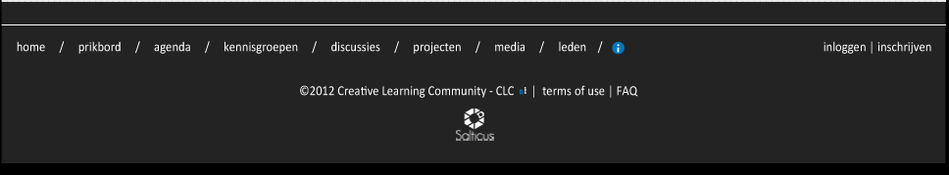
Achtergrond kleur | #242424
font weight: | bold
font color: | #ffffff
spacer: | /
login/inschrijven spacer: | |
CLC logo: | Logo_clc_klein.png
Salticus logo: | Logo_salticus.png

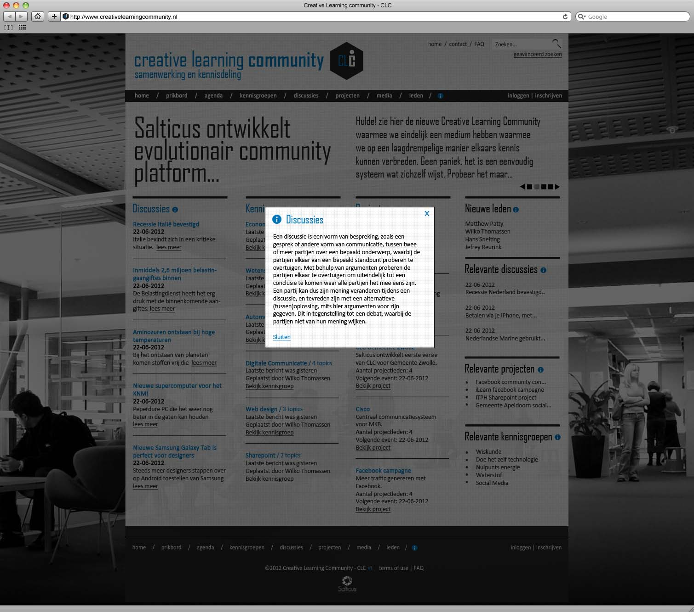
Popup
Close button
Button_popup_close.png
Info button
Button_info_20x20.png
Sluiten link:
Link color: #0077bd
Underlined: ja
Hover: #242424 underlined

